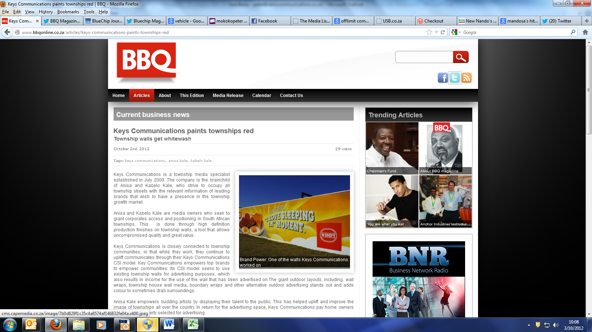

http://www.bbqonline.co.za/articles/keys-communications-paints-townships-red